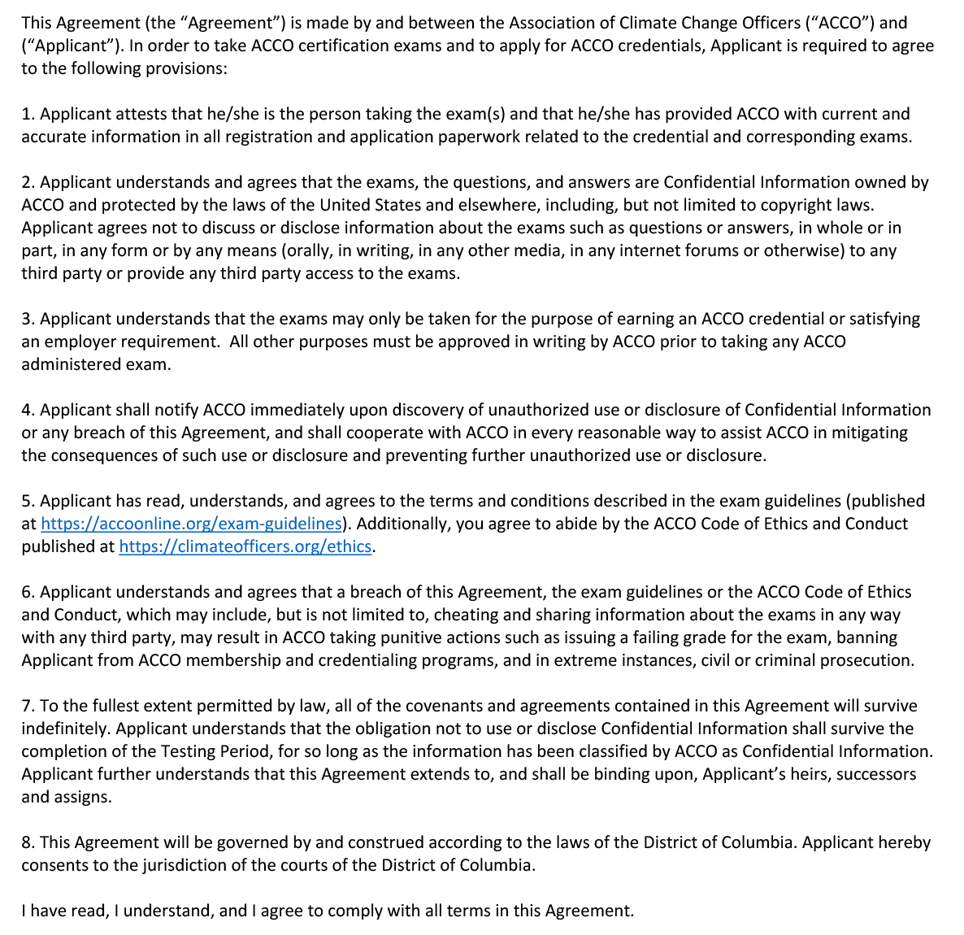

APPLICANT:

Signature: Address:
Full Name:
Date:

